**IST659- Database Administration Concepts & Database Management**

**Project on Pharmacy Management System**

By:

Ajinkya Gaddime.

Aryan Kakade.

Durgesh Kulkarni.

**Brief Overview**

**Project Description:**

JK Pharmaceuticals is a company which supplies medicines directly to the customers. The company needs to create a database so that they can manage their customers, employees, and medicine details. There are various challenges that are faced by a pharmaceuticals company such as to check the customer’s health history and previous medical orders such that they can avoid medical abuse. Additionally, to ensure that all their customers are purchasing medicines according to their prescription. To study all these challenges, our goal was to create a comprehensive system that could address the problems encountered in a modern pharmacy's day-to-day operations.

**Database Components:**

1. The Database consists of 10 tables. Along with tables it has 6 views and 2 triggers as an external data logic.

2. The database is designed for three types of users Customers, Employees and Doctors.

3. Customers component will have all the details regarding the customer including their payment methods and their membership details.

4. Employee component will have all the details regarding details of customers, doctors and employees. Employee also has an authority to approve order

5. Doctor component will have all the details regarding medicines and adding prescription for their patient.

6. Excluding these main components there are other small entities and views that will work as added features of our database

**Technology Components used:**

1. SQL: - To write all the queries for creating tables, updating data, adding foreign key constraints and to write down the Up Down queries.

2. Azure Cloud: - To create a database which will contain all the required tables so that everyone can access it remotely.

3. Power Apps: - To create a front-end UI for the project

4. Views: - To create tables by taking columns from other tables for completing business rules.

5. Triggers: - To update the medicine stocks automatically based on order placed or deleted.

**Conceptual diagram of model:**

Link:- [**https://drive.google.com/file/d/1QcEy_SqhbRwJkKpLVeiZve6DDQEg1n9Q/view?usp=share_link**](https://drive.google.com/file/d/1QcEy_SqhbRwJkKpLVeiZve6DDQEg1n9Q/view?usp=share_link)

**Logical Diagram of Model:**

Link : <https://drive.google.com/file/d/169W19az9t_-DNG95gXoiZLCEa3gBWoh1/view?usp=share_link>

**BUISNESS RULE:**

* A customer can order multiple medicines from his account.
* A customer can view the details of medicines.
* A customer can create a new account and enroll for new subscription.
* An employee can verify the order of customer by viewing prescription issued by doctor.
* An employee can reject or approved the order of customer.
* An employee can add or edit the doctor details.
* An employee can add new medicine in list.
* A doctor can issue or edit the prescription to customer/patient.

**Table Data:**

**Customers**

**Insurances**

**Orders**

**Payments**

**Employees**

**Memberships**

**Medicines**

**Manufacturers**

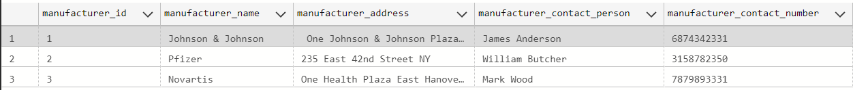

**Prescriptions**

**Doctors**

**DEMO of UI:**

Power App Link:- <https://apps.powerapps.com/play/e/default-4278a402-1a9e-4eb9-8414-ffb55a5fcf1e/a/6097917a-fc1a-49d6-9f0b-cd6656209c1f?tenantId=4278a402-1a9e-4eb9-8414-ffb55a5fcf1e>

**1. For customer login -**

**2. For Employee Login**

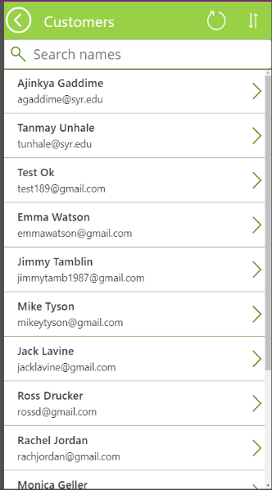**3.** **For Doctor Login**

